 | POSSIBLE TOPICS FOR ONGOING FORMATION
❐ | The Rule of the Secular Franciscan Order
❐ | Scripture (maybe studying the readings for the upcoming Sunday liturgy)
❐ | General Constitutions
❐ | History of the Penitential Charism
❐ | Saint Francis of Assisi
❐ | Saint Clare of Assisi
❐ | Holy Franciscan Women and Men (for example)
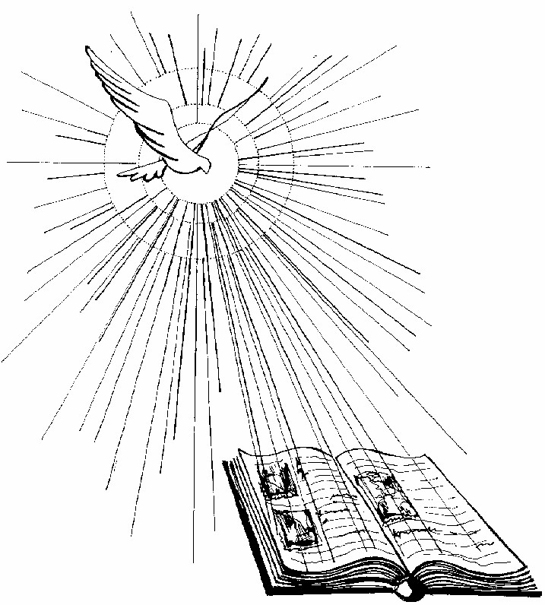
❐ National Statutes
❐ Ritual of the Secular Franciscan Order
❐ TAU-USA ongoing formation articles
❐ Franciscan Formation Texts
❐ Vatican II Documents ❐ Franciscan Spirituality
❐ Franciscan Prayer
❐ Franciscan Life
❐ Franciscan History
 | ❐ Saint Louis
❐ | Papal letters
❐ | Christology
❐ | Christian Spirituality
❐ | Servant Leadership
❐ | Materials from the Regional Formation Director
❐ | Ecology
❐ Saint Anthony
❐ Saint Bonaventure
❐ Blessed John Duns Scotus
❐ Blessed Angela of Foligno
❐ Saint Margaret of Cortona
❐ Saint Elizabeth of Hungary
❐ Family (families, marriage, parenting, sexuality)
❐ Peace and Justice
❐ Work (including economic justice)
❐ Youth and Young Adults
❐ Multicultural Responsiveness ❐ Vocations Promotion
❐ And the list goes on and on!!!
2005

