The Forbidden Fruit by Susan Burns – Care for Creation – August 1, 2016
A friend and I attended a symposium on wolves being held in West Yellowstone. In the United States there are no rights for nature and wildlife, as there is in other countries. Wolves and grizzlies are protected as endangered species, yet States can enact their own “shoot on site” laws. There is no evidence of malfeasance required. There is no consideration given to the part the animal plays in the larger ecosystem of sustainability in the environment. Man puts his will to protect his possessions, his will of domination over the animal kingdom, and his will to unilaterally decide the course of nature over God’s will to protect and nourish the gifts He has given us. To counteract, numerous wildlife organizations pursue legal action. Proof of injury is required to bring suit against agencies or persons harming the standards of environmental protection. The passing of local ordinances in violation of Federal law is also being challenged by The Native American Indian Freedom Religious Act. Each of us can contribute to the legal defense of nature and wildlife. Each of us can substantiate proof of injury by immediately journaling our feelings and observations. We need to be specific about what upset us; making exact notations of time and place of the injury. We need to submit our written documentation to one of the wildlife organizations involved in the legal pursuit of justice for nature and wildlife; Environmental Defense Fund, Nature’s Voice, National Wildlife Federation, etc.
Besides the avenue of legal justice, we also need to continuously work on changing hearts. We can do this by first building our relationship with God. We need to pray, to study forming ourselves in His Word, and to take action. We need to invite God’s Spirit to wrap our lives in His Will of Holiness so that His Will permeates our relationships with others, 24/7, in all our environments of family, social, work, church, nature, etc. We need to communicate God’s Will with confidence and conviction, absent of the forbidden fruits of arrogance and intimidation.
Before returning through the park (Yellowstone), we visited the Grizzly and Wolf Discovery Center. I was a bit apprehensive as I thought wild animals in captivity was 180 degrees opposite of what I had just learned. What I found out was that all the animals in the Center could not survive in the wild. Sam, the 22-year-old grizzly, was an orphaned cub rescued by the facility. I learned that bear research is aiding in the medical field; obesity and weight loss study of bear’s annual intense cycles of feeding to lose 25-40% of their body weight in hibernation, prevention of bone deterioration of bear’s 6 month’s hibernation of lying in a den and not losing bone or muscle tissue (I have a hard time moving every time I stand up), cardiovascular study of the bear’s intense increase in cholesterol during hibernation yet no hardening of the arteries, dissolving gallstones using the bile juice from hibernating bears (ursodeoxycholic acid), and new hope for kidney patients as hibernating bears have no need to eliminate body wastes. In the Lamar Valley at Yellowstone there is a den of wolves, 8 pups and 9 adults. I learned at the center that the pups lick the faces of the adults to make the adults regurgitate their food for the pup’s nourishment. I also learned that by fall the pups will be ready to move out and seek new habitat. I’ve escalated my intention to see the wolf pack before returning to Maryland in September.

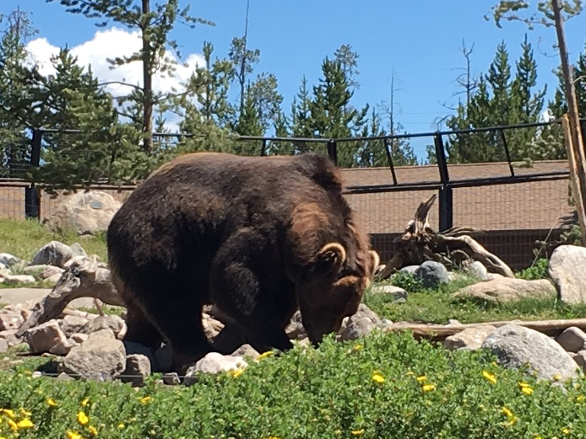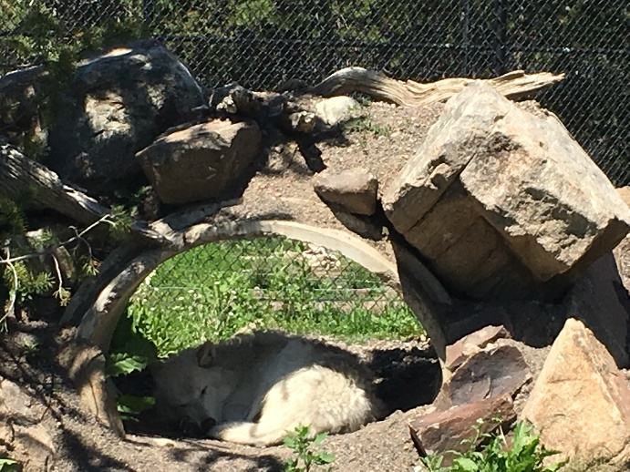
Sam, the grizzly at the Discovery Center searches One of the wolves at the Discovery Center
for food hidden by the staff to mimic the search
for food in the wild

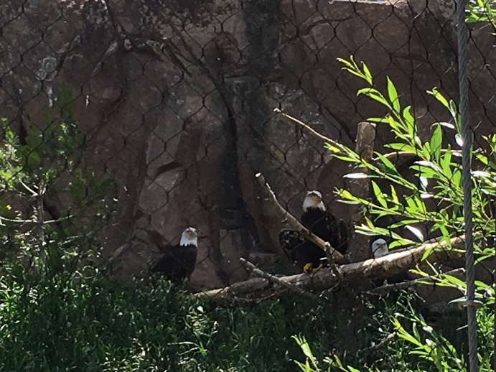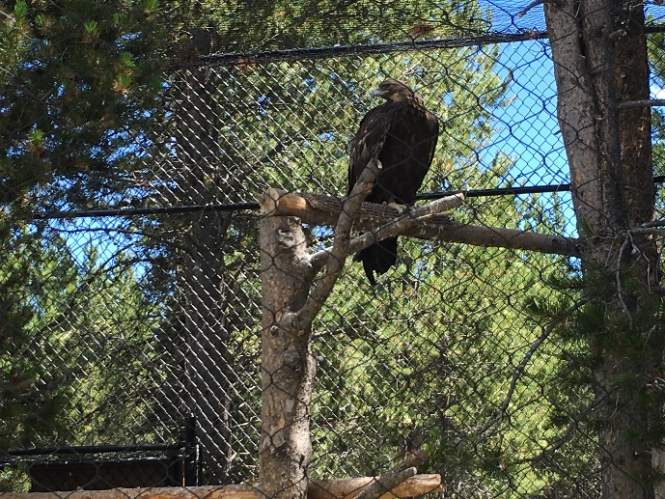

Eagles, hawks, and other birds are at the Discovery Center because of injury and the resulting inability to fly.

Following are recent pictures of God’s Creation seen in Yellowstone, primarily in the Lamar Valley.
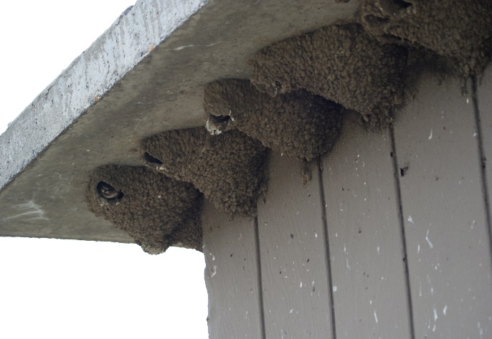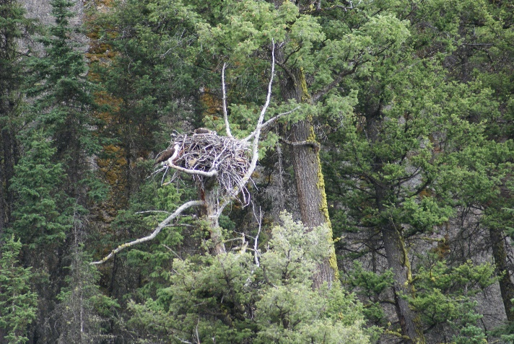
Swallow nests and babies Osprey family
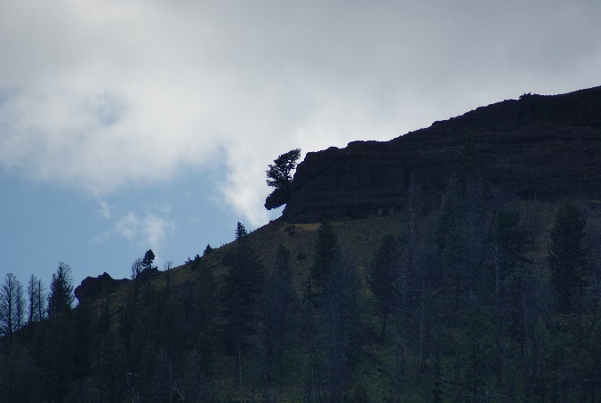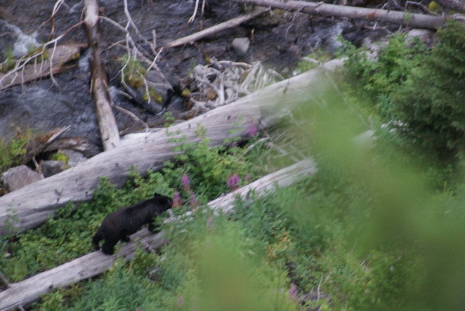

Tree Apparition of a Moose Head Black bear taking time to smell the flowers

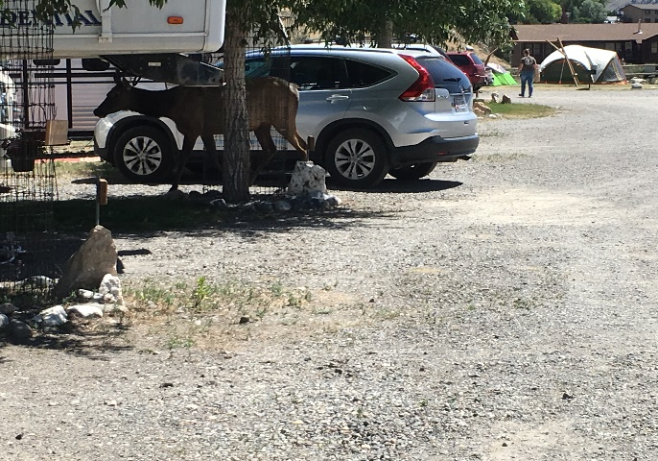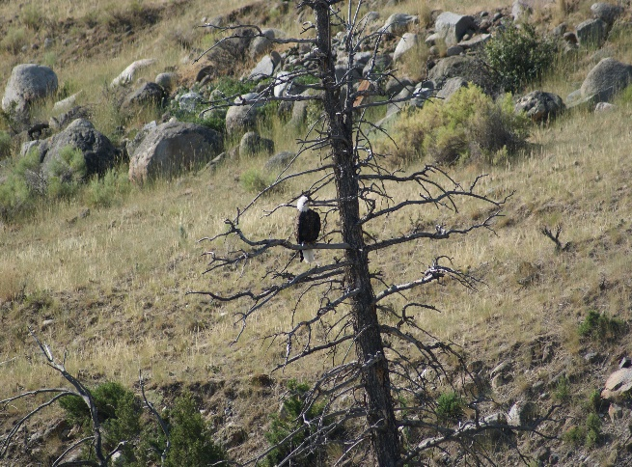
Elk visiting my car in the RV park Eagle across the Yellowstone River at RV park
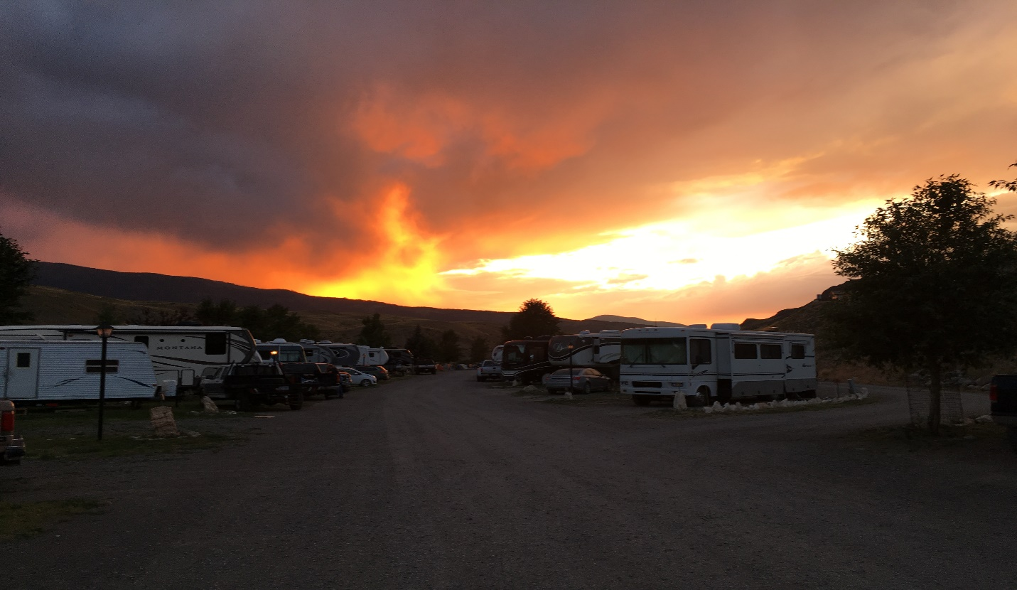
Sunset after waterless thunderstorm

