Care for Creation – The Chesapeake Watershed
June 6 2015
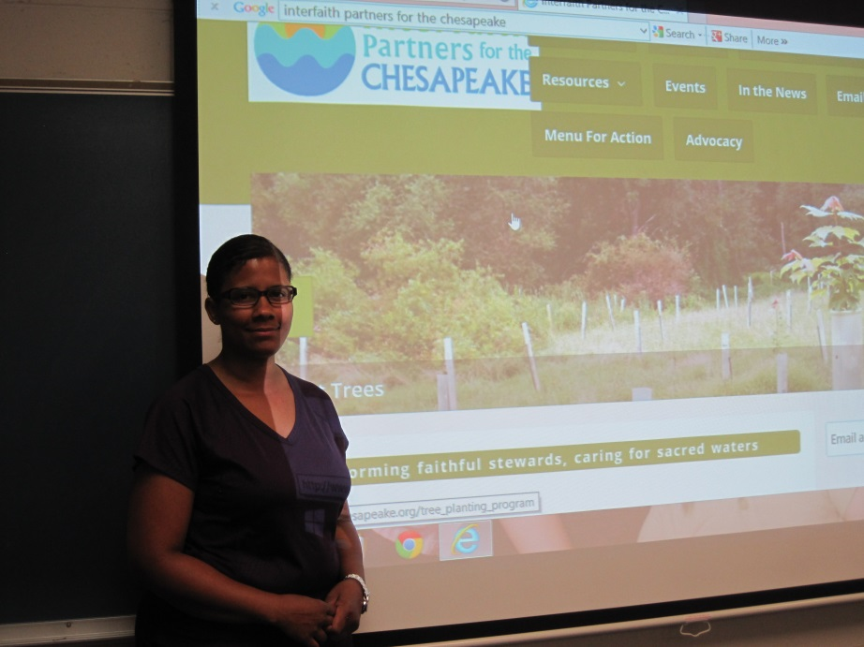

Holly Willis gave a very enlightening talk about what we can do as individuals to save our Chesapeake Bay where 1.7 million people live, play and earn their livelihood. In monetary terms, the Chesapeake is worth trillions of dollars. Holly’s experience as the chair of the environment committee at her daughter’s school, her Catholic faith sharing the Gospel message caring for the poor and her keen desire to utilize her computer skills and knowledge to search out answers and avenues to counteract the misuse of the environment enables each of us to look to her with confidence in what she has to say.

The number 1 polluter of the Bay is polluted runoff. The Chesapeake is the watershed for the entire Northeast and is affected by the contributions of each stream that flows directly or indirectly into the Bay. How many of you fertilize your lawns and garden before a rain, thinking the rain will drive the fertilizer into the soil. The rains will actually runoff down into the water table or down the drainage in the street carrying the toxins from the fertilizer with it. How many of you use insecticides and pesticides? These too pollute the water runoff into the water table or down the drain into the water flowing into the Bay. What can you do?

- Use organic fertilizer and fertilize when the dew is on the ground and no rain is predicted for 48 hours. Commercial lawn care companies know this to be a legal requirement, so if you contract care, be sure the company you use is following the law, and better still use a company that uses organic product. Using organic is important as the use of the word organic is regulated. Using natural does not give the same level of confidence as there are no regulations with the use of the word natural. FYI – it is the nitrous is fertilizer that is harmful.
- Instead of using commercial insecticides and pesticides, look up on line organic remedies for any issue you may have. Do you have crab grass? In early spring when the crab grass is first showing up, give it a spray of 2 teaspoons baby shampoo, 1 teaspoon molasses and 2 cups water. Then sprinkle baking soda over the grass. You can apply the baking soda by swinging and shaking a pantyhose foot filled with the baking soda over the affected area. For weeds, combine ½ gallon vinegar with 1 ounce orange oil with 1 squirt of liquid soap adding water to make up one gallon mixture.

Nitrous laden fertilizer and insecticides/pesticides may create a beautiful lawn and garden for your personal use, but Christ asks us to care for our brothers and sisters. This is the call to Social Justice that is part of our Catholic faith, part of Caring for Creation. Fertilizer and pollutants infect the water shed and the water table. That’s one of the reasons you probably use bottled water. The poor cannot afford to buy bottled water; they use water from the tap. Using organic fertilizer is one way of fertilizing your lawn. You can also introduce worm composting into your compost bin. (Come to the Care for Creation session on July 11 in a discussion of Waste Management lead by Dave Demers.) Then put the compost on your lawn and garden. To prevent storm water runoff, use rain barrels at all the gutters. Rain barrels can be purchased relatively inexpensively. Create a natural filter for your water runoff by planting a tree, creating a rock garden at low lying areas of your water runoff, and letting low lying weeds grow in the cracks of your sidewalks and driveways. Perhaps you have an area where water collects, a natural breeding area for mosquitoes and other “annoying pests.” Instead of deadly sprays, grow a rain garden. Dig out the area around the collected water making a berm and plant water loving plants such as weed grasses and milkweed. (The loss of milkweed to the use of Monsanto Roundup is creating a crisis or the Monarch butterfly, nearing extinction.) Our society constantly seeks higher yields and greater production and to satisfy that need farmers use the polluted water from the water table and spray insecticides and pesticides. You can buy organic or grow your own vegetables or go to a farmer’s market for fresh, locally grown veges. Buying organic is not in a poor person’s budget, even if you could find a grocery store selling fresh vegetables in lower income areas. Growing your own may not be an option as gardening soil is limited in lower income areas. For that reason, support of urban gardens and straw-bale gardening that does not require soil might be a viable solution for this problem. How can you support these gardening projects for your brothers and sisters? Going to a farmer’s market may not be an option as lower income areas depend on public transportation.

The negative effect of pollutants on the poor is evident by higher incidents of respiratory and dermatological diseases by airborne pollutants, higher incidents of cancer by the ingestion of pollutants, and higher incidents of learning and physical disabilities among the children of the poor. The higher incidents of disease and disabilities give rise to higher medical care needs for the poor who have less ability to pay for these needs. The cost to insure the poor is far less than the cost to ignore the needs of our brothers and sisters. The cost to protect the environment is far less than the cost to ignore the needs of our brothers and sisters. The poor have no voice, but you do. Do your part to protect the environment, especially the water running off into the watershed, in properly caring for your lawns and garden and keeping informed. Franciscan Action Network is a great website to include in your favorites. Write your congressional officials and president remembering that the poor do not have a voice, but you can be the voice of Christ for them. And PRAY! Recall the Scripture story of Joseph the 7th son of Jacob’s 12 sons, only God can turn every evil into good. (Genesis 50:19-20).

Following is a list of related websites:

http://www.interfaithchesapeake.org/

http://www.interfaithchesapeake.org/riverwise_congregations

http://www.cleanwaterhealthyfamilies.org/wp-content/uploads/2014/01/stormwaterinfographicFINAL.pdf

http://www.aawsa.org/

https://d3n8a8pro7vhmx.cloudfront.net/ipc/pages/52/attachments/original/1433785936/Stewards_of_the_Bay.pdf?1433785936

Peace and all good

