A Honey of a Story

The story of the Honey Bee is truly a miracle of God’s Creation.
God created a queen bee. She only mates once in her life and from that one encounter with the male bees (drones) she produces in her hive approximately 1,500 eggs per day up to 9 months of the year throughout her 4 – 6 year life.
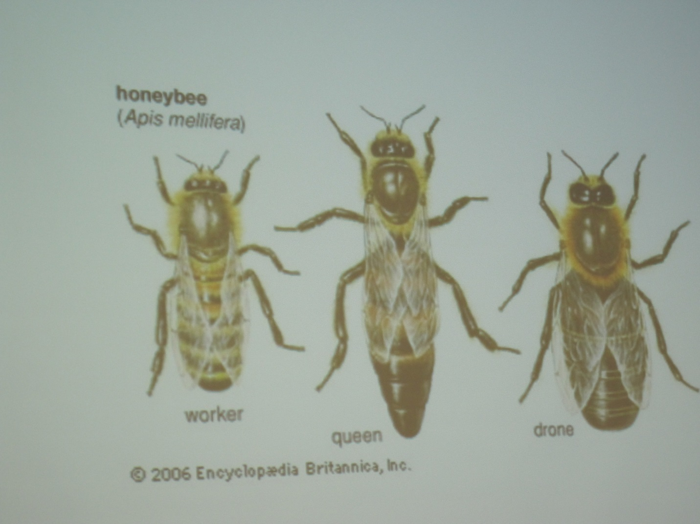

The fertilized eggs the queen produces are female bees (workers). The larvae grow in the cells within the hive and once the worker bees are generated, they immediately begin their first worker chore of cleaning the cells. They generate “bee sweat” to make bee wax and are the thermostat of the hive, flapping their wings in hot weather to keep the hive cooler and huddling and shivering in cold weather to heat the hive. The second phase of the worker bee is as guard bees, guarding the hive and the queen. The third and final phase of the worker bees is to become foragers. The worker bees fly out to the flowers in search of nectar.
The foraging worker bees are attracted to the nectar of the flower by the aroma of the nectar which is 20% sugar and 80% water and the color. The worker bees see ultraviolet light. A yellow peony to a human would have white outer pedals and a deep ultraviolet red for the nectar in the center to a worker bee. The forager worker bees zero in on the nectar and fill their stomach, going from flower to flower until their stomachs are filled to the brim when they return to the hive. The worker bees regurgitate the nectar they have collected, the water is evaporated in the hive making honey, 80% sugar and 20% water, providing food for the hive, honey and pollen.
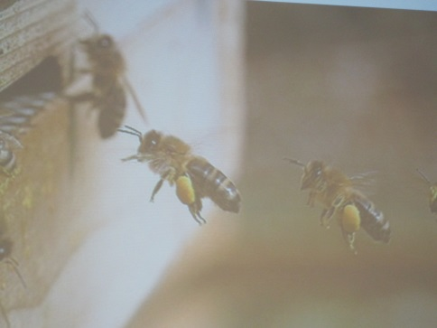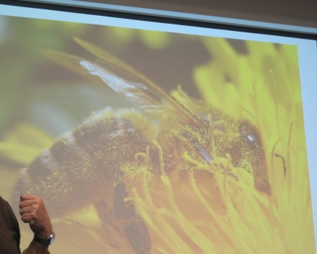
Pollen-laden legs – bee returning to the hive Pollen-laden bee “nectarizing”
As the forager worker bees go from flower to flower collecting nectar, pollen sticker to their hairy legs and backs. Some of the pollen is taken back to the hive with the nectar and since pollen is primarily protein, the pollen taken to the hive becomes another food source for the hive. As the forager goes from flower to flower, pollen is deposited in the flower becoming the male part of generating a seed for new life of a fruit or vegetable. This would include new life for alfalfa products which is used for cattle feed. Worker bees pollinate 71 of the 100 major crops that make up 90% of what we eat. 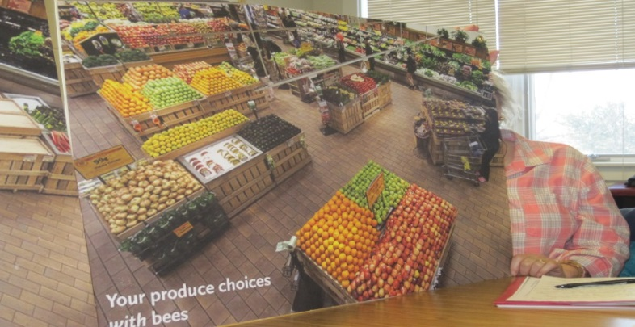 “Your produce choices with bees “
One out of every three bites of food we take depends on bees. Thank you Jesus for the Creation of bees.
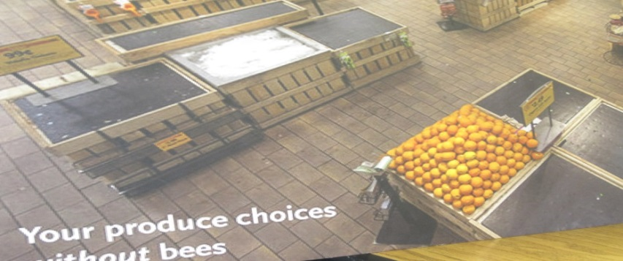“Your produce choices without bees”

When the hive gets too larger, the female worker bees will create 15-20 queen cells to “re-queen” the hive. When the first queen hatches, she goes out from the hive and mates. When she returns she will kill off the other queen cells. All the workers going with her to swarm and form a new hive, must touch her first. In this way, the swarm to a new hive will take on the new pheromone of the new queen.
The female worker bees literally work themselves to death; nursery bees for cleaning and regulating the hive temperature, guardian bees for protection of the hive and the queen, foraging bees to collect nectar, to pollinate flowers producing seeds, to produce honey, and to prepare the hive for a new queen and a new hive when the time is right. The female worker bees live 4 – 6 weeks, going away by themselves to die.
The unfertilized eggs of the queen are the male bees, drones. The drones do absolutely nothing but wait with other male drones for a virgin queen to come along. Drones are dirtier, bigger, fatter, and hairier than the females. The drones eat 3 times as much as the workers, they need to be taught how to eat, and the drones do not have a stinger. The drones live 3 to 5 months. They reside in the hive, only leaving to mate. Eventually, the workers will kick them out or kill them. During the winter months there are no drones in the hive.
The picture below is a bee hive. The central area are cells of fertilized eggs to become female worker bees. The larger cells at the top and bottom are the larger male drones. The grayish areas to the upper right and left is honey. The larger cell in the bottom left area is the creation of some queen cells.
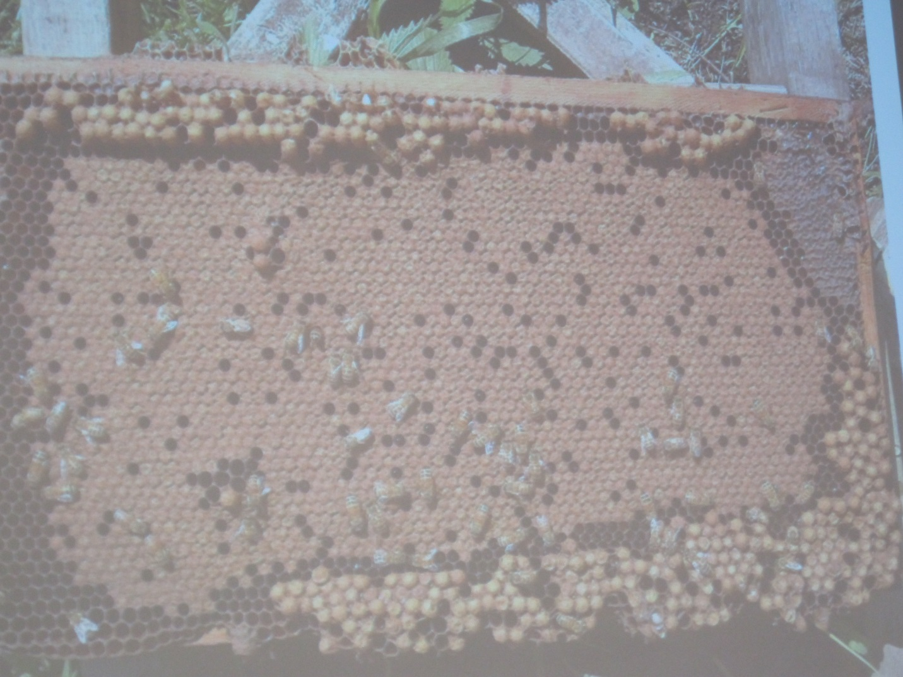

Bees are a necessary part of our lives, they are a miracle of God’s Creation. Bees are not aggressive unless provoked, but you must always use the proper precautions in handling the bees and the bee hive. Every one of us need to do our part in sustaining the cycle of food production God has provided us with the bees.
God’s Gift of BEES are dying off. Bees pollinate alfalfa hay and alfalfa seed, i.e. feed for dairy cattle. Scientist have modified the DNA so pollination is not needed from the bees. Our department of agriculture says that the GMO, genetically modified organism, are okay, yet they are banned in foreign countries. The results of the GMOs is dead bees, dying from digestive issues. Other problems are more prevalent in GMO areas, i.e. colon cancer in humans. It seems to me that GMOs are to provide an unnatural response to the declining bee population when we should look at restoring God’s plan and promote the natural cycle of bees to nectar to pollination to seed to new product.
There are diseases and pests, i.e. mites, killing off the bees, but the use of pesticide and insecticide to rid the bee population of these pests is not the solution. The use of pesticides also kills off the bees either directly or indirectly through the ingestion of pesticide riddled nectar. Also, the loss of habitat in the urbanization of the world diminishes the hive generating environments. The stress of re-location also is reducing the bee population. In the almond growing areas of California, bees are transported from one almond field to another, but bees need variety.
Pesticides: The amount sprayed on our fields has increased exponentially to more than 180 million pounds a year. Not only is the bee population declining, the use of glyphosate such as “Roundup” is destroying native milkweed that Monarch butterflies depend on for survival. Monarchs are the ONLY butterfly of more than 8,000 species in the Americas that migrate some 3,000 miles to Mexico for the winter. Their number has dropped from 1,000,000,000 (that is one billion) to 33,500,000 (that is 33.5 million).
Do whatever you can to protect God’s creation. Encourage our family, friends, and others to not use insecticides or pesticides. Encourage the production of insecticide/pesticide free produce by buying organic vegetables and fruits. Not only will there be a healthier you, you’ll be doing your part to sustain the bee population to sustain the production of healthier produce and animals.

